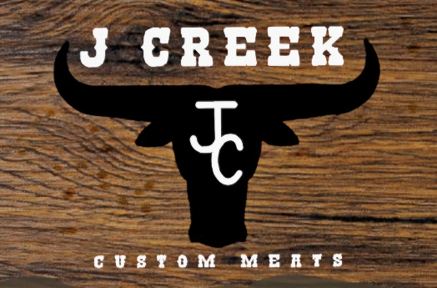

2025 Price Sheet

**Harvesting Charge**  **Kill-Only Fee**

Beef - $100 / head Beef - $150 Hog - $100

Hog - $90 / head

Lamb/Goat - $75 / head

*Price includes disposal fee*

**Processing Fee – All products are vacuum sealed & labeled**

$.95 / lb – Hanging carcass weight

*Minimum fee $150 per animal*

**Beef and Pork Additional Fees**

* *$20 for single pack steak/pork chop requests*
* *$20 for single pack bones*
* *$20 if cut sheet is not returned 48 hrs prior to cut date*
* *$30 split fee will apply if instructions require extra cut time based on multiple cut sheets*

**MEAT NOT PICKED UP WITHIN 10 DAYS OF BEING NOTIFIED BECOMES PROPERTY OF JCCM.**

**Cancellation Fee**

$150 fee for no-shows or cancel same day *(excludes certain circumstances)*

**Cooler Fee**

Request to hang animal longer than 10 days = additional $10/day

*\*Only applies if cooler space is limited\**

**Freezer Fee**

Animals not picked up on scheduled pick-up day will be charged an additional $15 per day *\*Only applies if freezer space is limited\**

**\*Please bring your own coolers or boxes for pick-up OR boxes are available for $3/box.\***